|  |  |  |  |  |  |  |  |  |  |  |  |  |  |  |  |  |  |  |  |  |  |
| --- | --- | --- | --- | --- | --- | --- | --- | --- | --- | --- | --- | --- | --- | --- | --- | --- | --- | --- | --- | --- | --- |
|  |  |  |  | ***KŘÍŽOVKA*** |  | 1. |  |  |  |  |  |  |  |  |  |  |  |  |  |  |  |
|  |  |  |  |  | 2. |  |  |  |  |  |  |  |  |  |  |  |  |  |  |  |  |
|  |  |  |  |  |  | 3. |  |  |  |  |  |  |  |  |  |  |  |  |  |  |  |
|  |  |  | 4. |  |  |  |  |  |  |  |  |  |  |  |  |  |  |  |  |  |  |
|  |  | 5. |  |  |  |  |  |  |  |  |  |  |  |  |  |  |  |  |  |  |  |
|  |  |  |  |  |  | 6. |  |  |  |  |  |  |  |  |  |  |  |  |  |  |  |
|  | 7. |  |  |  |  |  |  |  |  |  |  |  |  |  |  |  |  |  |  |  |  |
|  |  |  |  |  |  |  |  |  |  |  |  |  |  |  |  |  |  | 8. |  |  |  |
|  |  |  |  |  |  |  |  |  |  |  |  |  |  |  |  |  |  |  |  |  |  |
|  |  |  |  | 9. |  |  |  |  |  |  |  |  |  |  |  |  |  |  |  |  |  |
|  |  |  |  |  |  |  |  | 10. |  |  |  |  |  |  |  |  |  |  |  |  |  |
|  |  | 11. |  |  |  |  |  |  |  |  |  |  |  |  |  |  |  |  |  |  |  |
|  |  |  |  | 12. |  |  |  |  |  |  |  |  |  |  |  |  |  |  |  |  |  |
|  |  |  |  |  |  | 13. | **J** |  |  |  |  |  |  |  |  |  |  |  |  |  |  |
|  | 14. |  |  |  |  |  |  |  |  |  |  |  |  |  |  |  |  |  |  |  |  |
|  |  |  | 15. |  |  |  |  |  |  |  |  |  |  |  |  |  |  |  |  |  |  |
|  |  |  |  |  |  | 16. |  |  |  |  |  |  |  |  |  |  |  |  |  |  |  |
|  |  |  |  | 17. |  |  |  |  |  |  |  |  |  |  |  |  |  |  |  |  |  |



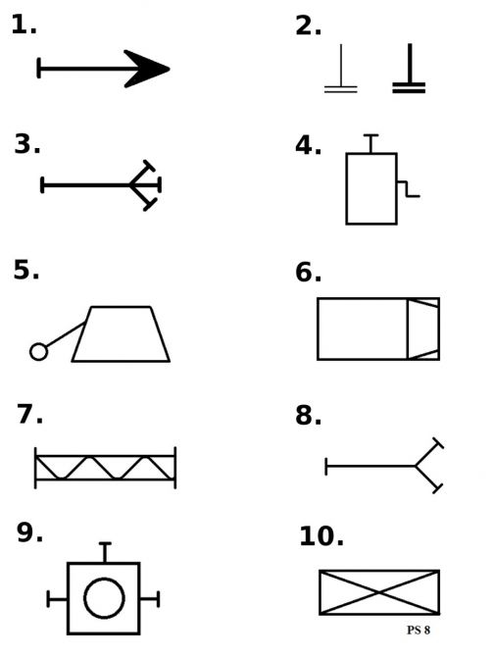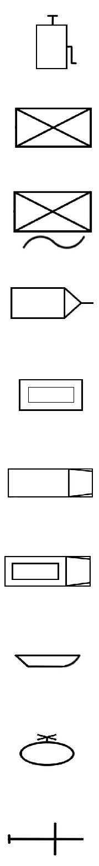

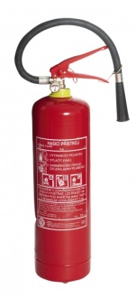

hovorově

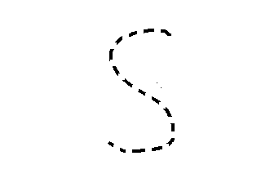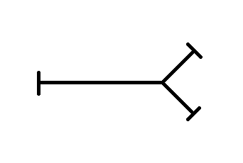

zdrobněle

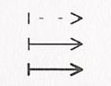

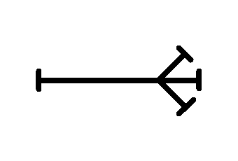 158

 150

zkratka 155

***Technické prostředky- spojovačka***

